AH_flat_GS_black_pc**Reed Canarygrass: Native… or NOT?**

Reed canarygrass (*Phalaris arundinacea)* is a rhizomatous perennial grass 1-2m tall, with panicles 7-40cm long protruding above the dense leaves. Its traits are variable, with at least 11 different cultivars identified (Waggy 2010). Reed canarygrass grows in various riparian habitats and forms dense monocultures that crowd out other plants. It is listed as “native” to the United States in the USDA NRCS Plants database (//plants.usda.gov/core/profile?symbol=PHAR3), but exotic on the Invasive Plant Atlas of the United States (Swearingen and Bargeron 2016) and is currently found in all but six of the lower 48 states. But is it native to our area? And if not, how concerned should we be about reed canarygrass?

National Park Service

U.S. Department of the Interior

Southeast Utah Group

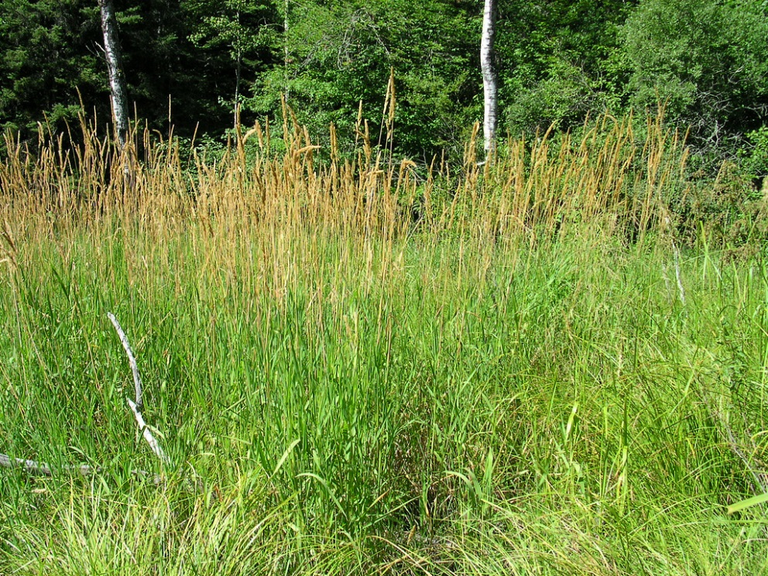 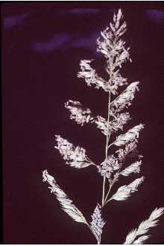

USDA Photo- Superior National Forest

Photo by Robert H. Mohlenbrock

A brief literature search reveals that there is much concern about the invasiveness of reed canarygrass, and also much debate on its nativity. Reed canarygrass is clearly native to Europe, and there is evidence from early herbarium records that it may be native to parts of the United States, particularly the inland Pacific Northwest (Merigliano and Lesica 1998). There is some indication that native populations were not invasive (Dore and McNeill 1980, Merigliano and Lesica 1998). However, European agronomic cultivars, bred for their fast and dense growth, have been imported since the 1850’s, and genetic studies suggest that current populations are either nonnative strains or overwhelmed by the nonnative genotypes (Broderson et al. 2008, Lavergne and Molofsky 2009). Furthermore, repeated introductions of different cultivars have produced high within-population genetic diversity that allows for natural selection of novel genotypes that increases the invasiveness of this species (Gifford et al. 2002, Lavergne and Molofsky 2007). A thorough review by Waggy (2010) best sums up results from discussions of reed canary grass nativity this way:

“*Native populations of reed canarygrass that have not been exposed to gene flow from nonnative strains may no longer occur in North America… Decisions to control populations of reed canarygrass may be based on its impacts in a given area rather than its ambiguous native status*.”

**Management considerations**

Reed canarygrass was introduced and still is used for purposes of forage and erosion control. Due to the sod-forming monocultures that it produces, reed canarygrass is an ideal candidate for mass ground cover. However it can be undesirable forage due to the high alkaloid concentrations in many strains, resulting in ill effects on grazers (Marten 1985, Osterm 1987). Reed canarygrass can also impede water flow, harming irrigation systems (Hodgson 1968, Bruns 1973). Its invasiveness can also result in many negative ecosystem impacts. For example, Lavergne and Molofsky (2004) reviewed a number of studies with overwhelming evidence for reduction of native vegetation cover and plant diversity that has cascading effects on invertebrates, birds, and other wildlife. Reed canarygrass clearly outcompetes other species in vegetation restoration projects (Bedelsky 2000, Green 2001). In addition, reed canarygrass growth increases with nutrients (Green 2002, Mauer and Zedler 2002), which could boost its invasiveness in areas with manure input from domestic grazing. Tamarisk increases soil nitrogen through sediment and litter accumulation (Adair et al. 2004), with even higher nutrient inputs in beetle-defoliated stands (Conrad et al. 2013). Could this have implications for managing reed canarygrass in our riparian areas, where tamarisk beetles are established and reed canarygrass appears to be spreading?

While the nativity of reed canarygrass to the United States may continue to be debated, we believe it is not native to the Colorado Plateau. There was no record of it in Arches or Canyonlands national parks until 2016, when it was noted in scattered locations along the Colorado and Green Rivers. It was then found it in two remote canyon locations in the parks in 2017. Reed canarygrass has formed dense monocultures in the populations we’ve seen, causing concern for the health and recovery of native riparian vegetation communities. The National Park Service – Southeast Utah Group is controlling it when possible, using herbicide due to its extensive rhizomatous root system. Waggy (2010) reviews a number of control methods; management of reed canarygrass may be considered on a case-by-case basis, using decision tools that guide invasive plant management activities.

*For more information about exotic plant management at Arches and Canyonlands national parks, contact: Liz Ballenger, Vegetation Program Manager (435) 719-2132, Liz\_Ballenger@nps.gov*

**References:**

Adair E.C., Binkley D., and D.C. Andersen. 2004. Patterns of nitrogen accumulation and cycling in riparian floodplain ecosystems along the Green and Yampa rivers. *Oecologia* 139: 108–16.

Brodersen, C, S. Lavergne, and J Molofsky. 2008. Genetic variation in photosynthetic characteristics among invasive and native populations of reed canarygrass (*Phalaris arundinacea*). *Biological Invasions*. 10: 1317-1325.

Bruns, V.E. 1973. *Studies on the control of reed canarygrass along irrigation systems*. Agriculture Research Service, U.S. Department of Agriculture Publications. ARS-W-3 1: 17.

Budelsky, R A. and S.M. Galtowitsch. 2000. Effects of water regime and competition on the establishment of a native sedge in restored wetlands. *Journal of Applied Ecology*. 37: 971-985.

Conrad B., Acharya K., Dudley T.L. and Bean D.W. 2013. Impact of episodic herbivory by the tamarisk leaf beetle on leaf litter nitrogen and stem starch content: a short communication. *Journal of Arid Environments* 94: 76–79.

Dore, W.G. and J. McNeill. 1980. *Grasses of Ontario.* Monograph No. 26. Ottawa, ON:

Agriculture Canada, Research Branch. 566 p.

Gifford, A.L., J.B. Ferdy and J. Molofsky. 2002. Genetic composition and morphological variation among populations of the invasive grass, *Phalaris arundinacea*. *Canadian Journal of Botany*. 80: 779-785.

Green, E.K. and S.M. Galatowitsch. 2001. Differences in wetland plant community establishment with additions of nitrate-N and invasive species (*Phalaris arundinacea* and *Typha xglauca*). *Canadian Journal of Botany*. 79: 170-178.

Green, E K. and S.M. Galatowitsch. 2002. Effects of *Phalaris arundinacea* and nitrate-N addition on the establishment of wetland plant communities. *Journal of Applied Ecology*. 39: 134-144.

Hodgson, J. M. 1968. Chemical control of reed canarygrass on irrigation canals. *Weed Science* 16: 465–468.

Lavergne S. and J. Molofsky. 2004. Reed canary grass (*Phalaris arundinacea*) as a biological model in the study of plant invasions. *Critical Reviews in Plant Sciences* 23.5: 415-429.

Lavergne S. and J. Molofsky. 2007. Increased genetic variation and evolutionary potential drive the success of an invasive grass. *Proceedings of the National Academy of Science*. 104: 3883-3888.

Marten, G. C. 1985. Reed canarygrass. In: Heath, M.E., R.F. Barnes, D.S. Metcalfe and S. Darrel, eds. *Forages: The science of grassland agriculture*. 4th ed. Ames, IA: Iowa State University Press: 207-216.

Maurer, Deborah A. and J.B. Zedler. 2002. Differential invasion of a wetland grass explained by tests of nutrients and light availability on establishment and clonal growth*. Oecologia*. 131: 279-288.

Merigliano, M. F. and P. Lesica. 1998. The native status of reed canary grass (*Phalaris arundinacea* L.) in the Inland Northwest, USA. *Natural Areas Journal* 18: 223-230.

Osterm, L. 1987. Studies on genetic variation in reed canarygrass, *Phalaris arundinacea*. I. Alkoloid type and concentration. *Hereditas*. 107: 235-248.

Swearingen, J. and C. Bargeron. 2016 Invasive Plant Atlas of the United States. University of Georgia Center for Invasive Species and Ecosystem Health. [http://www.invasiveplantatlas.org/](https://www.invasiveplantatlas.org/) (accessed 1/27/18).

United States Department of Agriculture Natural Resources Conservation Service. 2018. USDA NRCS Plants Database //plants.usda.gov/core/profile?symbol=PHAR3. Accessed 1/26/18.

Waggy, Melissa, A. 2010. *Phalaris arundinacea*. In: Fire Effects Information System, (Online). U.S. Department of Agriculture, Forest Service, Rocky Mountain Research Station, Fire Sciences Laboratory (Producer). https://www.fs.fed.us/database/feis/plants/graminoid/phaaru/all.html (12/14/17).

**Photos:**

Robert H. Mohlenbrock, hosted by the USDA-NRCS PLANTS Database / USDA SCS. 1989. Midwest wetland flora: Field office illustrated guide to plant species. Midwest National Technical Center, Lincoln. (//plants.usda.gov/core/profile?symbol=PHAR3)

United States Department of Agriculture, Superior National Forest. Hosted by Flickr. 2004. (//www.flickr.com/photos/superiornationalforest/5097358819/)